1. Many to Many always create 3 tables
2. 2 for Entity and 1 for relationship which takes Primary key of both tables
3. Note annotation @JoinTable its not @JoinColumn
4. And we use attribute joinColumns for adding PK of current Entity into 3rd table.
5. And use InverseJoinColums for adding PK of Second Entity into 3rd table.

I have used the Application of

Tourist App and Hotels

We have many tourist apps like (make my trip , trivago,yatra.com, expedia, etc etc)

All apps has many hotels listed their

And hotels using many tourist app for business promotions.

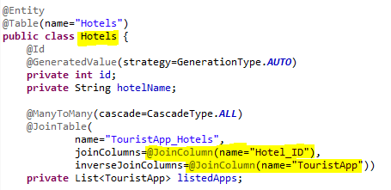

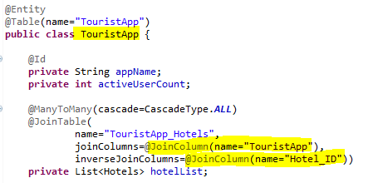

Look into the values   
both are swapped

